Name: _________________________________

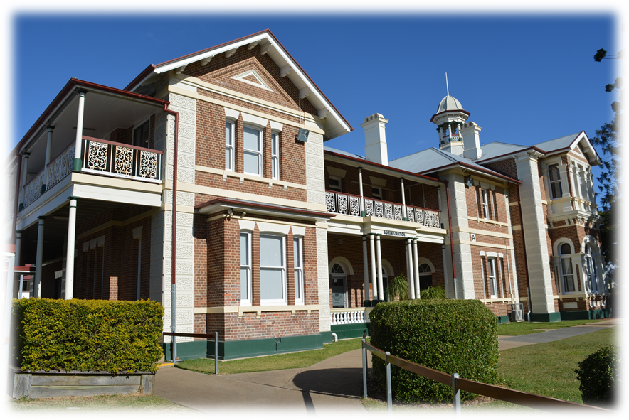

‘Aspire to Inspire’

Executive Student Leader
2026 Application Form
Return completed forms to Student Services.
DUE BY: 3:30pm, Friday 15 August 2025 (Term 3, Week 5).

“Leadership and learning are indispensible to each other” – John F. Kennedy
Name: |  | Form Class:
Sports House (circle one): Melville Russell Glasgow Horsburgh Barton Hyne Morton Harrington
Leadership Positions available. CROSS OUT all position you are NOT applying for.
School Captain | Junior Captain
School Vice-Captain | House Captains
Student Representative Council President | Creative Industries Prefect
Student Representative Council Vice President | School Community Prefect
What extra-curricular activities have you been involved in and when through your schooling years? (ANZAC Day, competitions, assisting around the school, committees, etc.)

What sporting teams or events have you been involved in or assisted with throughout your schooling years?

ATTACH a copy of your report card from last semester.
“Innovation distinguishes between a leader and a follower” – Steve Jobs
If selected as a school leader, what would you like to introduce or achieve at Maryborough State High School? (Write a paragraph outlining an idea and or project to make our school better)

Any additional information in support of your application? If you need more room, please add pages to the back.

Two of my grade’s triad who support my application are:
1.____________________________________________ Signed___________________________
2.____________________________________________ Signed___________________________
Personal Commitment:
I understand the goals and time commitments of the Executive Student Leadership Development Program. If selected I will devote the required time to attend all program activities and participate fully in all activities.
I will ensure that I wear my uniform in an exemplary manner, and maintain and/or improve my academic achievement while participating in this program.
Signature:_______________________________________ Date:___________________
Parent Signature:_________________________________________

“As we look ahead into the next century, leaders will be those who empower others” – Bill Gates

Student Leadership selection process

Step 1: Student Leadership process advertised throughout schoolwide community via parades, student notices, website and social media commencing Week 3, Term 3.

Step 2: Students nominate for a position through application form. Application forms to be submitted to Student Services by Friday Week 5.

Step 3: Behaviour records are checked and students are short listed by the Student Leadership Committee (Student Leadership Coordinator and Principal) by Monday Week 6.

Step 4: During Week 7, at year level parade, candidates present a 1-2 minute speech, outlining their strengths and their intentions as a member of the Executive Student Leadership Team.

Year level students cast preferential votes after the final speech via ballot papers.

NOTE – votes are NOT used to determine the positions of School Executive, but rather to give the selection panel more information to give a final determination.

Step 5: Staff are provided with ballots and access to videotaped recording of speeches to cast votes.

Step 6: Student Leadership Committee short list applicants to the top voted students. Outgoing School Executive offered opportunity to peruse applications and provide more input for selection panel to make determination.

Step 7: Week 9 Interview panel consisting of Principal, HOY or Deputy, Aspire Program Mentor and/or facilitator of specific role. Interview to be used to confirm voting or clarify if voting is close. Principal and selection panel have final decision in relation to appointment.

Step 8 Friday, Week 10: All nominees are invited to A block for announcement to students. Official email gets sent out to all staff at 3:00pm along with Social Media announcement.

School Captain/s  Year 12 in 2026  Facilitated by Aspire Program Mentor |  | The position of School Captain at Maryborough State High School is the pinnacle of student leadership in the school. The Captains represent the student body and the whole school; its values, its good name and honour. They are able to inspire others and enjoy the confidence and respect of students and teachers.  Roles and Responsibilities:  - Meeting with Aspire Program Mentor as per schedule and engagement in online tasks/forums  - Attend and represent school at school and community events, in particular Anzac Day main parade  - Lead weekly senior parades  - Attend P & C Meetings on a regular rotation  - Attend Year 7 Form Classes every Wednesday Term 1  - School service: Good Morning Start program, Tuckshop and/or Café as rostered.  - Attend Fraser Coast School Captains Network breakfast each term
 | Vice-Captain/s  Year 12 in 2026  Facilitated by Aspire Program Mentor |  | As well as representing the student body, the Vice Captains represent the whole school, its values, its good name and honour.  Roles and Responsibilities:  - Meeting with Aspire Program Mentor as per schedule and engagement in online tasks/forums  - Attend and represent school at school and community events, in particular Anzac Day main parade  - Lead weekly senior parades  - Attend P & C Meetings on a regular rotation  - School service: Good Morning Start program, Tuckshop and/or Café as rostered.  - Attend Year 7 Form Classes every Wednesday Term 1  - Attend Fraser Coast School Captains Network breakfast each term
 | SRC President  Year 11 or 12 in 2026  Facilitated by Senior Teacher |  | The SRC is a conduit for all students having a voice and being active participants in the Maryborough SHS community. Focuses on fundraising for school needs and local, national and international charities  Roles and Responsibilities  - Represent the student body at school, district, and civic meetings  - Develop agenda for and preside at Student Council meetings  - Knowledge of the basic rules of parliamentary procedure  - Displays academic integrity and exemplary conduct  - Fundraising  - School service: Good Morning Start program, Tuckshop and/or Café as rostered.  - Attend Year 7 Form Classes every Wednesday Term 1  - Attend and present SRC Report at regular P & C Meetings  - Completes SRC Student report for P & C as required  - Attend Fraser Coast School Captains Network breakfast each term
 | Junior Captain/s  Year 9 in 2026  Facilitated by Aspire Program Mentor |  | As well as representing the student body, the Captains represent the whole school, its values, its good name and honour.  Roles and Responsibilities:  - Meeting with Aspire Program Mentor as per schedule and engagement in online tasks/forums  - School service: Good Morning Start program, Tuckshop and/or Café as rostered.  - Lead weekly Junior parades  - Attend and represent school at school and community events, in particular Anzac Day Dawn Service, Remembrance Day and Vietnam Veterans ceremony, etc  - Attend Year 7 Form Classes every Wednesday Term 1
 | House Captains  Years 10-12 in 2026  Facilitated by the Sports Coordinator |  | Good sportsmanship and leadership of their respective House Teams.  Roles and Responsibilities:  - Leadership of their House for all school carnivals  - Meeting with Aspire Program Mentor/Sports Coordinator as per schedule  - Presentation on senior and junior assemblies  - Promotion of House Spirit with a focus on Spirit Week activities in the Term as determined by the yearly schedule.  - Working as House Captaincy group for annual House Cup  - Development of activities and opportunities for house points eg lunchtime sporting activities  - Attend Year 7 Form Classes every Wednesday Term 1  - School service: Good Morning Start program, Tuckshop and/or Café as rostered.
 | School Community Prefect  Years 10-12 in 2026  Facilitated by Senior Teacher and/or Aspire Program Mentor |  | As well as representing the student body, the Prefects represent the whole school, its values, its good name and honour in all parts of the community.  Roles and Responsibilities  - Setting annual agenda re participation/organisation of school wide and community events (ie Harmony Day, Naidoc week)  - Recruiting students for these respective causes  - Organise PSC rewards days  - School service: Good Morning Start program, Tuckshop and/or Café as rostered.  - Attend Year 7 Form Classes every Wednesday Term 1
 | Creative Industries Prefect  Years 10-12 in 2026  Facilitated by HOD Creative Industries |  | Roles and Responsibilities  - Oversees and supervises all activities for the Arts in the school  - Reports to HOD Creative Industries  - Organises school parades with assistance of HOD Creative Industries  - Advocates for the Arts in the school  - Works with the HOD Creative Industries to create an annual Arts Plan  - Organises Creative Industries activities during lunchtimes  - School service: Good Morning Start program, Tuckshop and/or Café as rostered.  - Attends Year 7 Form Classes every Wednesday Term 1

House Captains

Tick the events that you attended this year | What should a House Captain be doing at these events? | Why would you be good at this? | What are some new ideas you have about these events?
Carnivals
- Swimming
- Cross Country
- Athletics
- House Spirit

Lunchtime House Events
- Futsal
- Dodgeball
- Basketball
- Dance
- Quiz
- Spelling Bee
- Ultimate Frisby
- Volleyball
- Others – List here:

Teacher vs Student Games
- Volleyball
- Netball
- Basketball
- Softball
- Others – list here:

Why do you think you would make a good House Captain?

